REMEMBRANCE SUNDAY

Sunday 9th November 2025

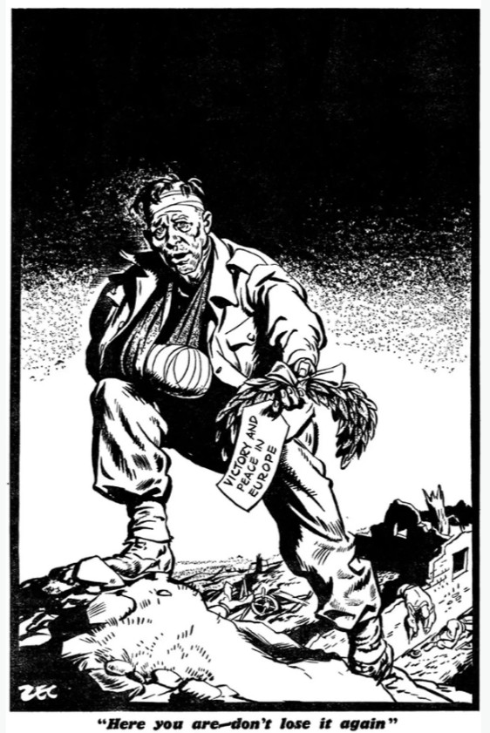

VE Day (Tues 8 May 1945) Daily Mirror front page

Act of Remembrance
The War Memorial
Buckingham Parish Church

All are welcome for refreshments at the Community Centre after the service

This Order of Service is available to follow online here


WELCOME & OPENING THOUGHTS
Major The Reverend William Pearson-Gee
Rector of Buckingham
Historical research by Major Philip Sturtivant (Rtd)

Hymn:

I vow to thee, my country, all earthly things above

Entire and whole and perfect; the service of my love;

The love that asks no question; the love that stands the test,

That lays upon the altar the dearest and the best;

The love that never falters; the love that pays the price

The love that makes undaunted the final sacrifice.

And there's another country, I've heard of long ago,

Most dear to them that love her, most great to them that know;

We may not count her armies, we may not see her King;

Her fortress is a faithful heart, her pride is suffering:

And soul by soul and silently her shining bounds increase

And her ways are ways of gentleness and all her paths are peace.

INTRODUCTORY PRAYER

The Parade will then be brought to Attention

THE ACT OF REMEMBRANCE

The Exhortation – Major Philip Sturtivant (Rtd)

They shall grow not old as we that are left grow old: Age shall not weary them nor the years condemn. At the going down of the sun
and in the morning: We will remember them.

All: We will remember them.

LAST POST - THE SILENCE – REVEILLE

Trumpeter: Lawrence Brody

The Parade will be stood at Ease

PRAYER – Major John Parry (Salvation Army): Almighty and Eternal God, who has made known his love for us in Jesus Christ, we thank you that you hear our prayers as we honour those who laid down their life in defence of our freedom. Father, we pray that you would enable us to follow the example of courage, loyalty and self-sacrifice set for us by those we remember today, through Jesus Christ our Lord. Amen

THE WREATH LAYING (during which the piper will play)

Prayer: Ever-living God, we remember those who you have gathered from the storm of war into the peace of your presence; may that same peace calm our fears, bring justice to all peoples and establish harmony amongst the nations, through Jesus Christ our Lord. Amen

Hymn:

1. O God, our help in ages past,
Our hope for years to come,
Our shelter from the stormy blast,
And our eternal home.

2. Under the shadow of Thy throne
Thy saints have dwelt secure;
Sufficient is Thine arm alone,
And our defence is sure.

3. A thousand ages in Thy sight
Are like an evening gone,
Short as the watch that ends the night
Before the rising sun.

4. Time, like an ever-rolling stream,
Bears all its sons away;
They fly forgotten, as a dream
Dies at the opening day.

5. O God, our help in ages past,
Our hope for years to come,
Be Thou our guard while troubles last,
And our eternal home.

REFLECTION

Minister: As we read the names of the fallen from two World Wars, let us remember before God, and commend to His safe keeping not just them but all those how have died for our country through acts of terrorism and in war and also those who now live with injuries suffered through their service.

The Names of the fallen are read.

PRAYERS – Led by Revd Ope Ayileye:

Each prayer will end with “may God give peace”

all please respond with God give Peace

THE LORD'S PRAYER
Our Father, which art in heaven,
hallowed be thy name:
thy kingdom come; thy will be done;
in earth as it is in heaven.
Give us this day our daily bread.
And forgive us our trespasses,
as we forgive them that trespass against us.
And lead us not into temptation;
but deliver us from evil.
For thine is the kingdom, the power and the glory,
for ever and ever. Amen.

THE ACT OF COMMITMENT

Minister: Let us pledge ourselves anew to the service of God and our fellow men and women; that we may help, encourage and comfort others, and support those working for the relief of the needy and for the peace and welfare of the nations.

ALL: Lord God our Father, we pledge ourselves to serve you and all people, in the cause of peace, for the relief of want and suffering, and for the praise of your name. Guide us by your Spirit; give us wisdom; give us courage; give us hope and keep us faithful now and always. Amen. The Parade will be brought to Attention
THE BLESSING
THE NATIONAL ANTHEM  God save our gracious King,  long live our noble King,  God save the King!  Send him victorious,  happy and glorious,  long to reign over us,  God save the King! | The Parade will re-form.  To allow this to take place quickly,  the congregation is asked to remain  in place and keep clear of the roadway between the Church gates until  the youngest children forming the tail of the Parade are clear of the Churchyard.

